Solvers As A Concept

Joints and Constraints

<what is a joint/constraint… High level maybe with pictures of possible constraints?>

The Solver

As more constraints are implemented in the physics system, there becomes a need to be able to solve all constraints at the same time. This equates to solving all the linear equations at one time, and in fact (as can be seen from the implementation later) is implemented as such.

The reason a global solver is so important rather than just sequentially solving each constraint can be best described with the following example. If we look at the following case, we have two balls trailing behind a box, constrained together by distance constraints (c1, c2).

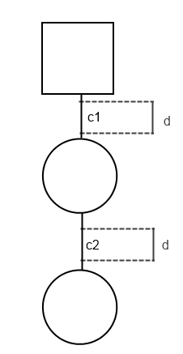

Now when we solve the constraints individually we can see that as the second constraint (c2) is solved, it itself invalidates the first constraint (c1).

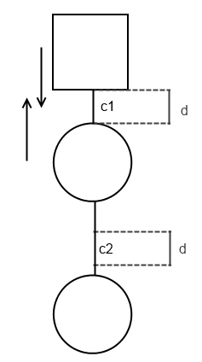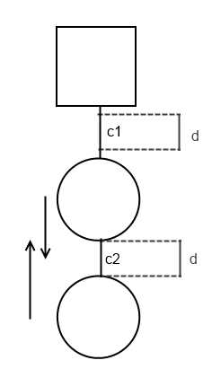

So in order to truly solve this problem we would have to make a constraint that solved both c1 and c2 at the same time. However, what if this problem was extended to have 3 or more balls trailing behind the box?

So instead of having to write bespoke constraints which take in more and more coupled objects, we can instead use a global solver to produce a result that satisfies all individual constraints in the system at once.